**Supplementary Information**

**Title:** **Exploring Sperm Cell Rheotaxis in Microfluidic Channel: The Role of Flow and Viscosity**

Dhiraj B. Puri1, Paul Jacob1, Vadiraj Hemadri1, Arnab Banerjee2 and Siddhartha Tripathi1#

1Department of Mechanical Engineering Birla Institute of Technology and Science-Pilani, K K Birla Goa Campus, Zuarinagar, Sancoale, Goa-403726, India

2Department of Biological Sciences, Birla Institute of Technology and Science-Pilani, K K Birla Goa Campus, Zuarinagar, Sancoale, Goa-403726, India

**Content**

**S1. Curvilinear velocity of the sperm cell.**

**S2. Average velocity or rheotaxis velocity of the sperm cell.**

**S3. Simulation study of sperm cell head at different location within the microfluidic channel.**

**S4. Videos related to the motion of sperm cell motion during rheotaxis.**

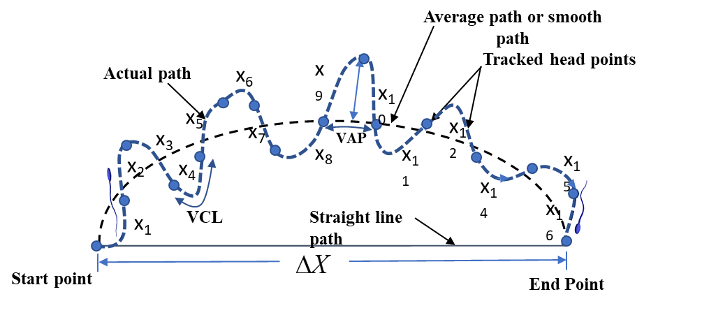

**FIG. S1. Kinematic parameters of sperm trajectory (VCL, VAP) were tracked using ImageJ.**

**S1. Curvilinear velocity (VCL)**: It is the total distance travelled by the sperm head (obtained by summing the position of the sperm head) calculated over equal time intervals divided by the total time between the first and last point of the path traced.



**S2. Average velocity or sperm rheotaxis velocity:** The velocity of the sperm cell during rheotaxis is the average path velocity of the sperm cell over the smooth path calculated using a five-point moving average.

To obtain the smooth path shown in Fig. S1, the positions of five neighbouring points were averaged at each acquisition point, and the 5-point moving average was then used as the corresponding sperm point on the path. It filtered out high-frequency lateral head displacement, better representing the sperm cells average position along the track.

. 



**S3.** **Simulation study of sperm cell head at different location within the microfluidic channel.**

To calculate the drag on the sperm cell head simulations were performed by placing it at different location within the microchannel shown in Fig. (S2-S4). The corresponding meshing



**Fig S2. Sperm cell head near side wall (NSW) of the microchannel.**



**Fig S3. Sperm cell head at the centre of the microchannel.**



**Fig S4. Sperm cell head near top wall of the microchannel.**

**S4. Videos related to the motion of sperm cell motion during rheotaxis.**

Video 1: Rheotaxis of sperm cells in the bulk region and near-wall region of the microchannel.

Video 2: Reorientation of sperm cells against the flow to perform the rheotaxis.

Video 3: Motion of the sperm cell without external flow.

**References:**

1. Hong, Y. C., Lee, F. M., Ou, C. M & Chao, T. H. Tail beat frequency of human sperm: Evaluated with sperm head fixation method and computer-assisted sperm analysis. Archives of Andrology, 30, 171-176 (1993)
2. Sloter, E., Schmid, E. T, Marchetti, F., Eskenazi, B., Nath, J. & Wyrobek, J. A. Quantitative effect of male age on sperm motion. Human Reproduction, 21(11), 2868-2875 (2006). 
3. Mortimer, T. S., Schoevaert, D., Swan, A. M., Mortimer, D. Quantitative observation of flagella motility of capacitating human spermatozoa. Human Reproduction, 12(5), 1006-1012 (1997).